PROJECT REPORT
HUNGRY SNAKE
Premium Browser-Based Snake Game
A modern cyberpunk arcade game featuring responsive controls,
multiple game modes, power-ups, local scoring and animated gameplay.

Submitted By | Azizullah
Course / Program | AI-Driven Development, Claude Code, and OpenClaw Fundamentals
Instructor | Sir Ammar Aamir
Institute | www.Panaversity.org
Submission Date | 26-06-2026

ARCADE SERIES • WEB GAME DEVELOPMENT

1. Project Introduction
Hungry Snake is a premium browser-based arcade game inspired by the classic Snake concept. The project transforms traditional snake gameplay into a modern cyberpunk gaming experience with a neon interface, animated canvas rendering, multiple game modes, power-ups, difficulty settings and responsive controls. The game is designed to run directly in a modern web browser without requiring a backend server.

2. Project Objectives
The main objective of this project is to develop an interactive, visually attractive and responsive browser game using modern front-end web technologies. The project demonstrates real-time game logic, collision detection, score management, user input handling and persistent browser storage.
- Create smooth and engaging Snake gameplay for desktop and mobile users.
- Provide multiple game modes and difficulty levels for replay value.
- Use a modern neon cyberpunk and glassmorphism user interface.
- Store high scores and local game statistics in the browser.
- Implement special food, power-ups and dynamic speed progression.
- Organize the application using reusable React and TypeScript source files.

3. Tools and Technologies Used
Technology / Tool | Purpose | Project Use
React | User interface development | Builds and manages the game interface and application structure.
TypeScript | Typed programming language | Provides safer game logic, interfaces and reusable data types.
Vite | Front-end development tool | Provides fast development, project startup and optimized builds.
HTML5 Canvas | 2D game rendering | Displays the snake, food, barriers, portals and visual effects.
CSS | Interface styling | Creates responsive layouts, glassmorphism and neon cyberpunk effects.
JavaScript / Browser APIs | Game interaction | Supports animation, controls, audio and browser functionality.
Local Storage | Browser-side storage | Preserves high scores, records and local statistics.

4. Project Structure
The source code is organized into separate folders and configuration files. This modular structure makes the application easier to understand, maintain and extend.
- assets — stores project media and visual resources.
- src/components — contains reusable interface and game components.
- src/utils — contains helper functions and supporting game utilities.
- App.tsx — main application component and primary game interface.
- index.css — global styling, responsive layout and visual theme.
- main.tsx — application entry point.
- types.ts — TypeScript types and game-related data definitions.
- index.html — base HTML document loaded by the browser.
- package.json — project dependencies and development scripts.
- tsconfig.json — TypeScript configuration.
- vite.config.ts — Vite development and build configuration.

5. Game Interface and Dashboard
The main dashboard uses a three-column gaming layout. The left side provides game mode selection, difficulty controls, a power-up guide and the local Hall of Fame. The center contains the Canvas game board, start controls and an on-screen directional pad. The right side displays the current score, high score, level, selected game mode and score multiplier.
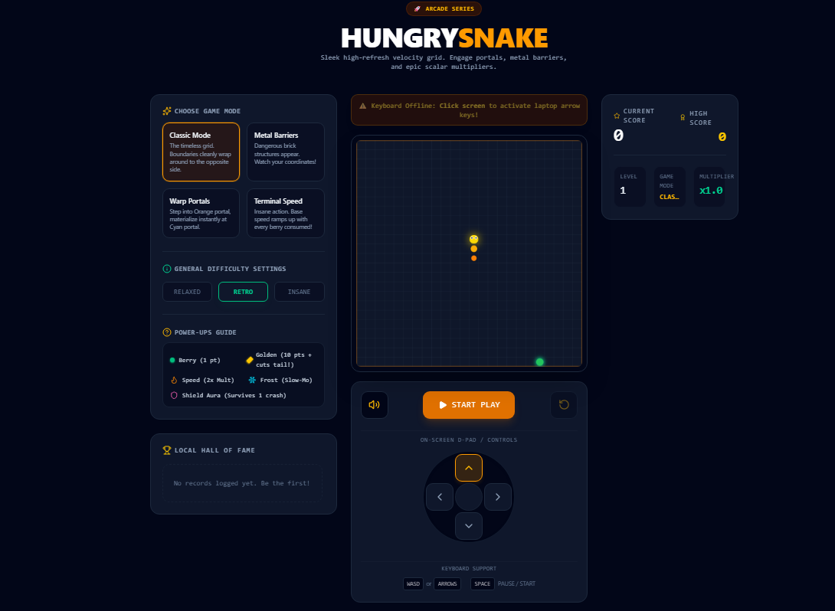

Figure 1: Hungry Snake main game dashboard and cyberpunk user interface.

6. Game Modes
Game Mode | Description
Classic Mode | Traditional snake gameplay with boundaries wrapping around to the opposite side.
Metal Barriers | Adds dangerous brick structures that the player must avoid.
Warp Portals | Introduces orange and cyan portals for instant teleportation.
Terminal Speed | An intense mode where speed pressure increases as food is consumed.

7. Difficulty Settings
The game provides three general difficulty settings. Relaxed mode is suitable for beginners, Retro provides balanced classic-style gameplay, and Insane is intended for players who want faster and more challenging gameplay. Difficulty selection affects the overall gameplay experience and speed pressure.

8. Food and Power-Ups
- Berry — standard food that increases the score and supports snake growth.
- Golden Food — valuable bonus food that awards additional points and supports multiplier or bonus gameplay.
- Speed Power-Up — temporarily changes speed behavior and creates a faster gameplay effect.
- Frost Power-Up — provides a slow-motion style effect for improved reaction time.
- Shield Aura — protects the snake from one crash or collision, depending on the active game state.

9. Controls and User Interaction
Hungry Snake supports both desktop and touch-oriented interaction. Keyboard users can control the snake using the Arrow Keys or WASD keys. The on-screen directional pad provides visible controls for touch devices. The interface also includes pause/start interaction, sound control and game reset functionality. The responsive design allows the dashboard and controls to adapt to different screen sizes.

10. Core Game Features
- HTML5 Canvas based real-time game rendering.
- Responsive desktop and mobile-friendly interface.
- Smooth animation loop designed for high-refresh gameplay.
- Dynamic speed progression as the game becomes more difficult.
- Current score, high score, level and multiplier tracking.
- Local Hall of Fame and browser-based score persistence.
- Multiple game modes and difficulty levels.
- Special golden food and power-up system.
- Particle and glow-based visual effects.
- Sound controls and gaming-oriented audio interaction.
- Animated gameplay states and modern cyberpunk presentation.

11. Technical Working of the Game
The application starts from main.tsx, which loads the React application and renders the main App component. App.tsx coordinates the major game interface and gameplay state. TypeScript types are maintained in types.ts so that game data can be handled consistently.
The HTML5 Canvas is used as the real-time game area. During gameplay, the application repeatedly updates the snake position, checks user direction, detects food collection and evaluates collisions. After the game state is updated, the Canvas is redrawn to display the latest frame. This update-and-render cycle produces smooth animated gameplay.
Collision logic determines whether the snake interacts with food, barriers or other game elements. Score and level values are updated according to gameplay events. As progression increases, speed can dynamically change to make the game more challenging. Browser Local Storage is used to preserve high-score or local record information even after the page is refreshed or reopened.

12. User Interface Design
The visual design follows a dark cyberpunk gaming theme. Neon green, cyan and orange accents create a glowing arcade appearance. Glassmorphism-style panels use translucent dark surfaces, borders and subtle visual depth. The game board uses a technical grid background, while compact labels and dashboard cards provide a modern gaming interface.
The layout separates configuration, gameplay and statistics into clearly defined areas. This improves usability because the player can select a mode, view power-up information, play the game and monitor performance from a single dashboard.

13. Responsive Design and Compatibility
The project is developed as a browser-based front-end application and does not require a backend database or server-side processing for normal gameplay. Modern browser technologies allow the game to run locally after the project is built or served through the development environment. Responsive styling and touch-oriented controls make the interface suitable for both desktop and mobile screens.

14. Project Outcome
The project successfully demonstrates how a classic arcade concept can be redesigned with modern web development technologies. Hungry Snake combines game programming concepts with responsive interface design, browser storage, typed application logic and real-time Canvas rendering. The result is an interactive game that is visually modern, technically organized and suitable as a front-end web development project.

15. Conclusion
Hungry Snake is a complete modern browser gaming project that extends traditional Snake gameplay through multiple modes, difficulty settings, special food, power-ups and a cyberpunk dashboard. React and TypeScript provide an organized application structure, Vite supports the development workflow, and HTML5 Canvas enables real-time game rendering. The project demonstrates practical skills in front-end development, game logic, responsive design and interactive browser application development.

